Project 6 – Secure Containers
What was Implemented

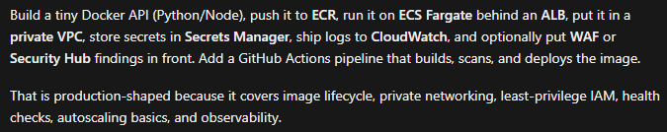
Installed Docker Desktop 4.93
Installed WSL (Windows SubSystem for Linux) Backend 2.7.14

Why use flask as the base app vs gunicorn/uWSGI from the start?
They’re not two competing “base apps.” They do different jobs.
- Flask = the application (routes like /health, your Python logic)
- Gunicorn / uWSGI = a server process that runs that application
Gunicorn doesn’t replace Flask. It loads your Flask app and serves it. Without an app framework (Flask, FastAPI, Django, etc.), Gunicorn has nothing meaningful to run.
We started with Flask alone because:
- Fewer moving parts for Phase 0 — prove Docker works with one simple process
- Flask includes a tiny built-in server (Werkzeug) that’s fine for local/lab demos
- Later you can keep the same Flask code and only change how it’s started:

Differences that matter
- Gunicorn / uWSGI speak Python’s WSGI interface. They run your Flask app. They are not full-featured public edge servers (TLS termination, caching, etc. are weaker or secondary).
- nginx is a high-performance edge/proxy. It usually does not run Flask itself; it forwards to Gunicorn/uWSGI. Great at HTTPS, load balancing, static files, buffering.
- IIS is the Windows equivalent of that edge/web role. Common in Microsoft shops; less common inside Linux Docker/ECS labs like Project 6.
For Project 6: ECS + ALB already plays the “front door” role (like nginx/IIS for routing/health checks). Gunicorn would replace Flask’s built-in server inside the container. You don’t need nginx and ALB unless you want an extra proxy layer.
What Docker Desktop did
Docker Desktop wasn’t only for building — it did three jobs in this lab:
- Build the image from the Dockerfile
- Run it locally (Phase 0 tests on port 8080)
- Push that local image to ECR (docker push talks to your local Docker engine)

Implementation Step-by-Step
Step 1 — Build (on your PC)
From the app/ folder:
docker build -t project6-api:local .
What that does:
- Reads Dockerfile
- Pulls base image python:3.12.7-slim-bookworm
- Copies requirements.txt / main.py, installs Flask, creates non-root user
- Stores the result locally as project6-api:local
At this point the image exists only on your machine (Docker Desktop), not in AWS yet.
Step 2 — (Optional) Run locally
docker run --rm -p 8080:8080 -e APP_SECRET=local-demo-secret project6-api:local
That starts a container from the local image so you can hit /health and /info. Useful to prove the image works before uploading.

Step 3 — Create the ECR “bucket” for images (Terraform)
cd ...\project-6-secure-containers\terraform
terraform apply
That created the empty AWS repo: project6-api.
Still no image in AWS until you push.
Step 4 — Log Docker into ECR
aws ecr get-login-password --region us-east-1 |
docker login --username AWS --password-stdin 345485442145.dkr.ecr.us-east-1.amazonaws.com
This gives your local Docker permission to push to your account’s registry.
Step 5 — Tag (rename for ECR’s address)
docker tag project6-api:local 345485442145.dkr.ecr.us-east-1.amazonaws.com/project6-api:latest
Same image, second name pointing at ECR. latest is just the tag label.
Step 6 — Push (upload)
docker push 345485442145.dkr.ecr.us-east-1.amazonaws.com/project6-api:latest
Docker Desktop uploads the image layers to ECR. After that, AWS has a copy ECS can pull in Phase 2 — your laptop doesn’t need to stay running.
Flow in one picture
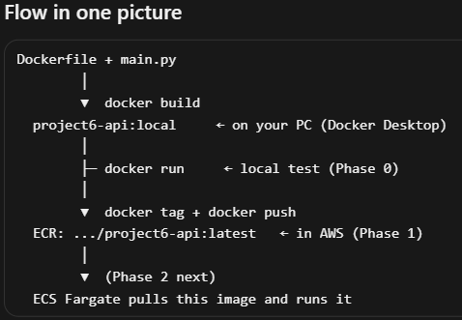
Phase 2
Test these:
- Health: project6-lab-alb-1609487481.us-east-1.elb.amazonaws.com/health → {"status":"ok"}
- Info: project6-lab-alb-1609487481.us-east-1.elb.amazonaws.com/info → hostname + secret_configured: true
What Terraform added
- VPC + 2 public subnets (no NAT)
- ALB on port 80 → target group health check /health
- ECS cluster/service, 1 Fargate task (0.25 vCPU / 512 MB)
- CloudWatch logs: /ecs/project6-lab-api
- Cost: ALB + Fargate are billing while this stays up. When you’re done for the day, say if you want me to terraform destroy or scale to 0.

